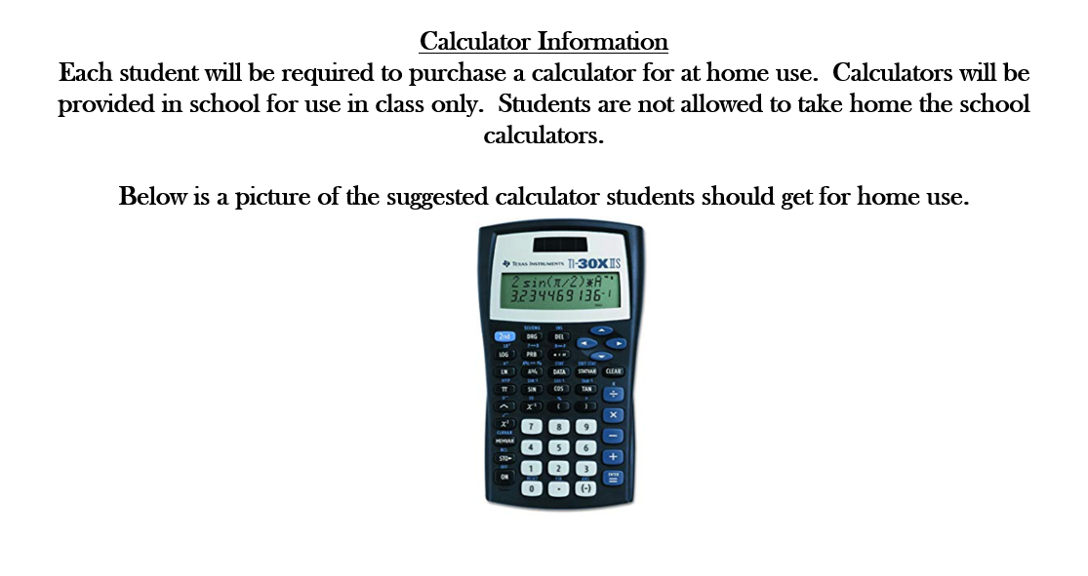

**CLASS CALCULATORS WILL BE DISINFECTED AFTER EVERY USE PER CLASS BY CLASSROOM TEACHER**